Strategy

In my Comp-XM round Decisions, I know, that competition is going to be very high among the competitors, as Baldwin is competing in all segments of the market which are Thrift, Core, Nano and Elite. Chester is competing in only two segments of market which are Nano and Elite with higher price. Digby is also competing in two primary segments which are thrift and core with low price.

I have decided, I will also compete in all segments of market but I will compete through unique designs, Technology and improved performance and will charge little higher than my competitors. So, My Company Andrew will follow the strategy of Broad Differentiator.

Research and Development

There are only 4 rounds in this Compxm, but I have decided I will add more products in order to grab more market share. Therefore, I will add minimum 3 more products more named as **AA1, AA2** and **AA3** along with my other four products Acre, Adam, Aft, and Agape. I feel, by adding more new customize product, I can gather more market share than with few products offered by my company Andrew.

Marketing

One of the key factor in making product successful is based on how well, company markets its product, it is useless to have a good product but don’t market it well. So, Brand marketing and availability of my products are extremely important to keep the demand level with the production. My strategy will be to keep the public as close to 100% on accessibility and awareness, for all of my products. I plan on doing this by investing into the marketing aspects of my company. Using the Comp-XM Inquirer to predict how much marketing is needed to raise the awareness and accessibility as well as make up for lost awareness from the previous year.

Production

My automation level is low as compared to my other competitors, because my main focus is to invest in my HR and then produce the quality output rather than investing in automation, because it is very costly to install.

At the end of the round 2, my current contribution margin is 38.7% as per the Comp-XM Inquirer Round 2 report. Till the last round of the comp-xm, my target is to maintain such healthy contribution margin, because my company is covering its all the period cost from this margin. As my main focus is to compete with my competitors with performance, quality and design, So, that will be strategy for all 4 rounds.

Finance

My strategy for financing would be sale of stock, because it invests greatly back into the company while providing a connection to the public. Understanding how to invest in stocks is very tricky. I want to issue just enough stocks to cover some of the costs of changes to the production and factory investments to be able to avoid loans. I’d like to keep the number of issued stocks around 60% of my authorized stocks, reserving 40% for future investment. Ideally I’d like to keep 30% of the stocks owned by the company. If necessary I will plan to take out a short-term loan, because they cost less in the long term for my company.

Markets

In this comp-XM, there are 4 markets, where competitors are competing named as Thrift, Core, Nano and Elite. Each market’s customers has its own buying criteria and preferences, which I will analyze and follow to meet their needs.

**Nano Market Buying Criteria**

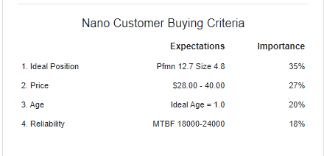

For Nano Segment customers, most important buying criteria is that company meets their performance and Size criteria, which is 35% important for them and Least important factor is Reliability which is 18% important.

**Thrift Market Buying Criteria**

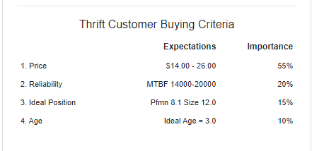

Thrifts customers are very price sensitive and for them, prices of the products must be low and within their range which is 14-26$ and is 55% importance and least important is Age of the product which is 10% important.

**Core Market Buying Criteria**

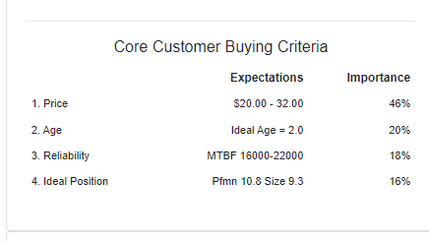

Core market customers are ready to pay little higher price than thrift and it is also very important criteria of buying for them as it 46% importance and at last is ideal position which is 16% important.

**Elite Market Buying Criteria**

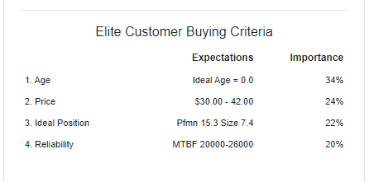

Elite customers are richer customers of the market, and age is most important for them as its 34% important and Reliability is 20%